  - Bike Station Sharing Data — Analysis Report

This report analyses 2,856 bike-sharing stations across 25 cities worldwide, covering data from 2022 to 2025. The analysis reveals significant variation in station performance, utilization rates, and cost efficiency across cities.

Power BI Dashboard:

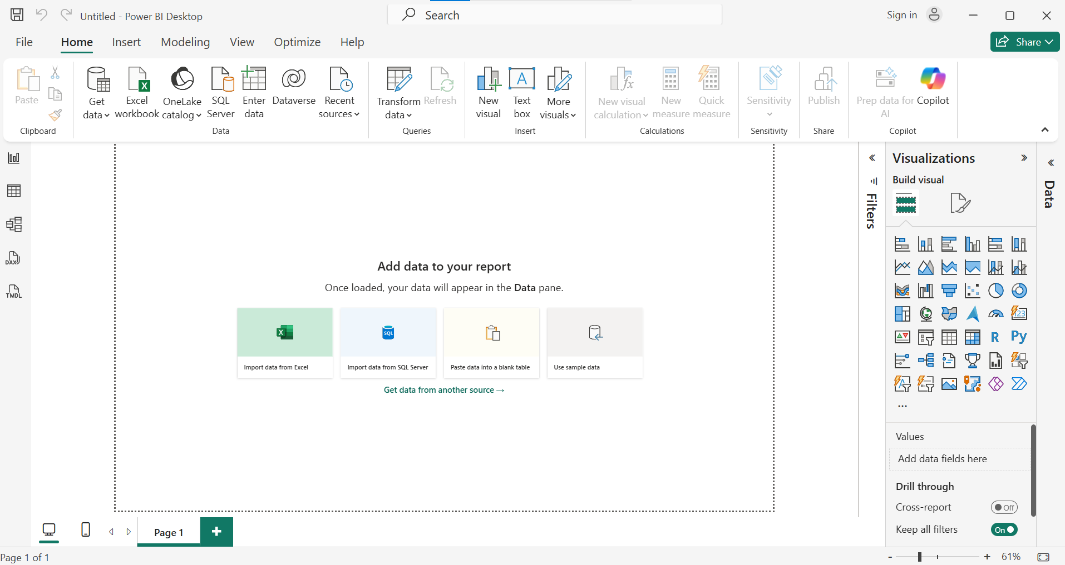

Navigator Power Query:

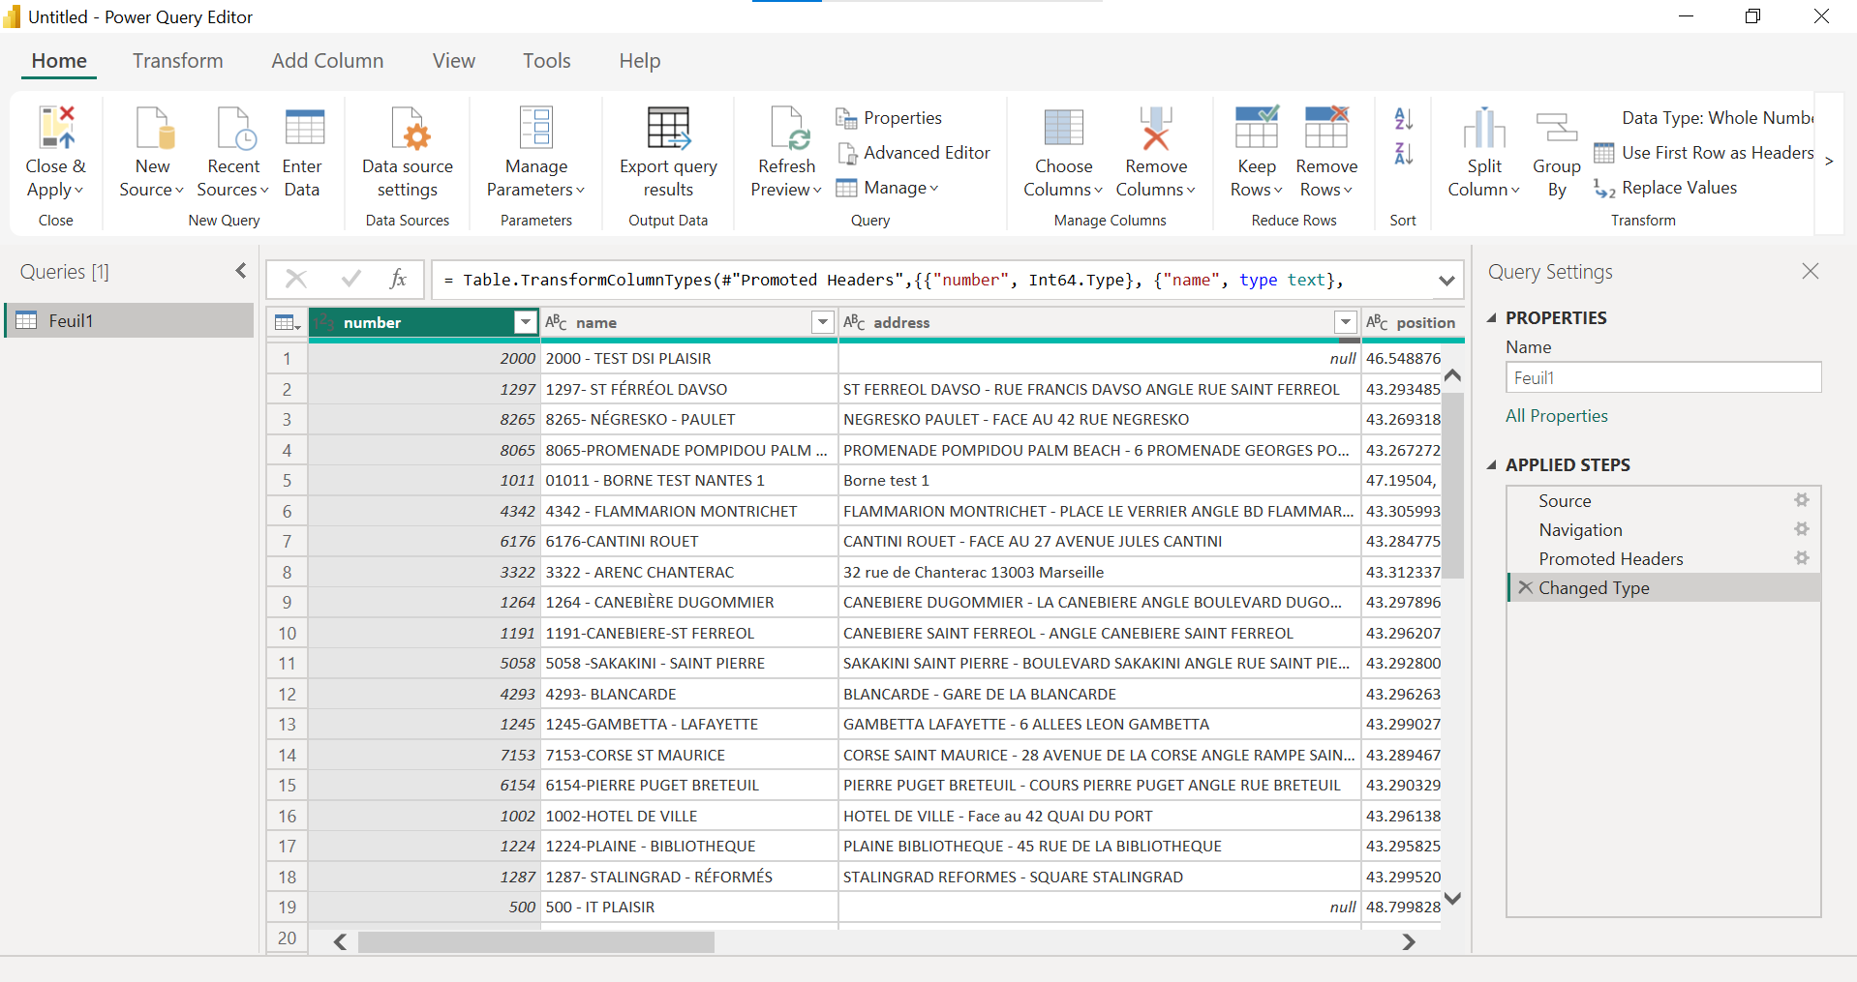

Power Query:

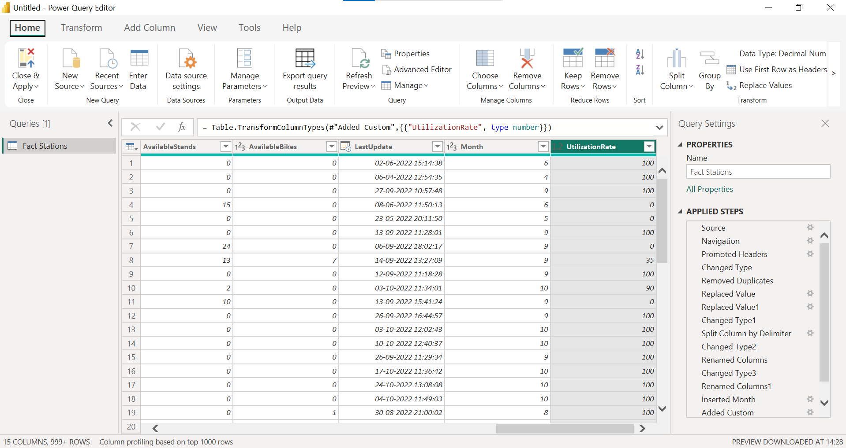

Data_ Model:

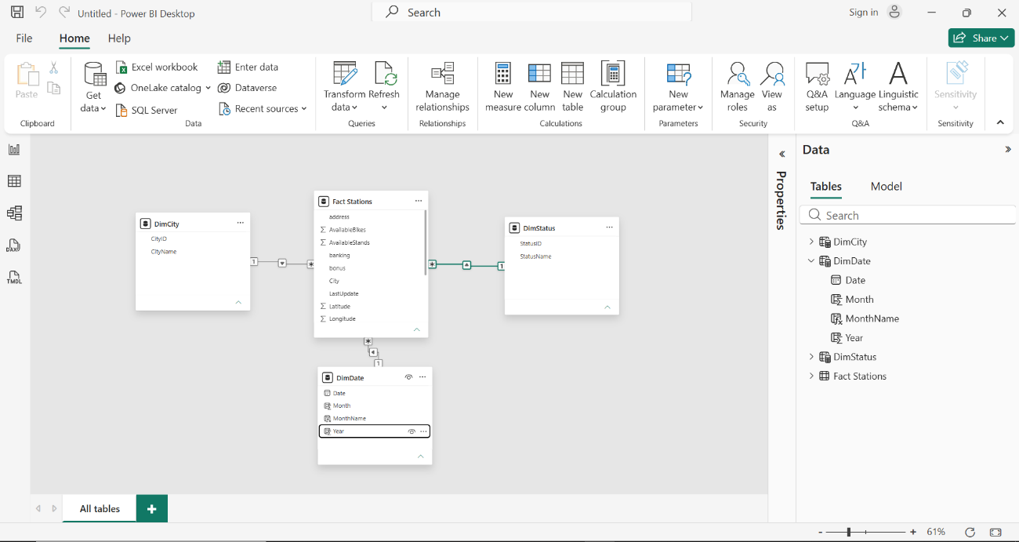

Dax Measures:

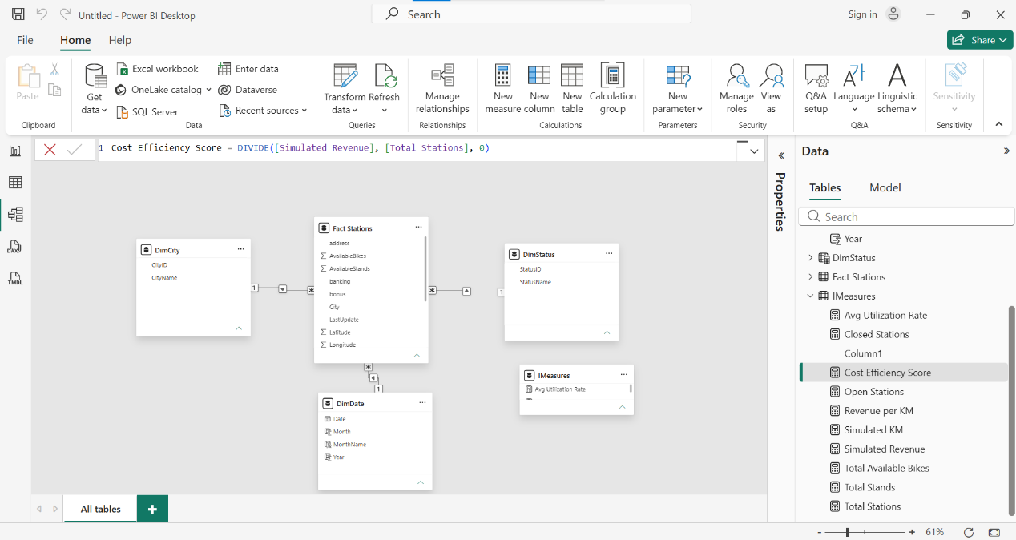
Dashboard:



